**AIM**: **Draw the Data Flow diagram and specify the role of each of the processes, External entities and data source.**

**DATA FLOW DIAGRAM:**

**(Bus Reservation System)**

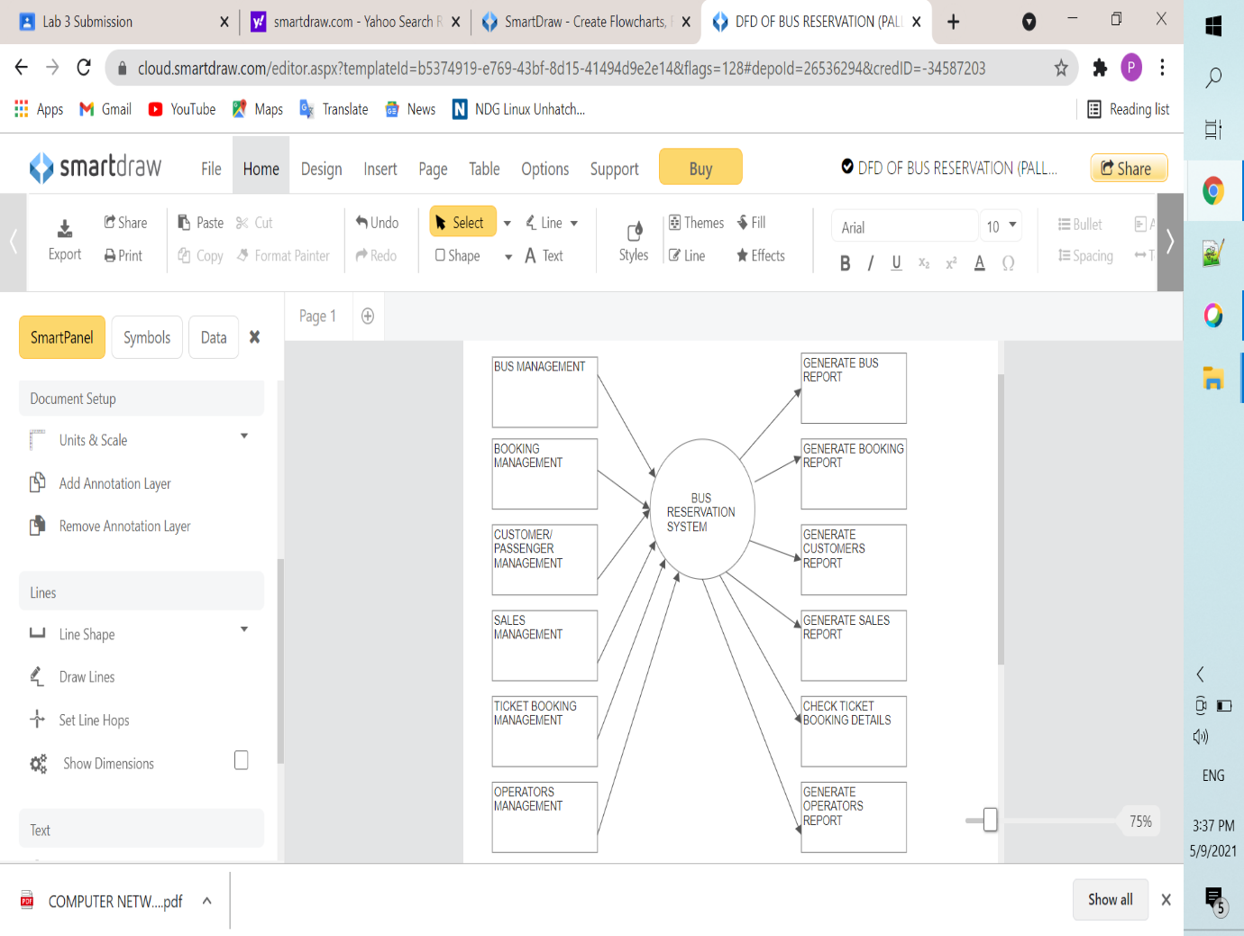

The data flow diagrams are pictorial or graphical representation of the Online Bus Ticket Reservation System.

The data flow diagram covers all the processes and data storage area, which takes place during any transaction in the system.

It’s a basic overview of the whole **Bus Reservation System** or process being analysed or modelled. It’s designed to be an at-a-glance view of customer, bus route and payment showing the system as a single high-level process, with its relationship to external entities of Booking and Ticket counter.

Main Entities and processes flow of Bus Reservation System:

* Processing bus schedule records and generate report of all bus schedule
* Processing booking records and generate report of all booking
* Processing Ticket Counter records and generate report of all ticket
* Processing customer records and generate report of all customer
* Processing bus route records and generate report of all bus route